ASSIGNMENT-1 SOLUTION

Q1. Explain the difference between frontend, backend, and full-stack development with
suitable real-world examples.

ANS :-

• Frontend Development: Deals with the part of the website
that users see and interact with. It includes designing layout, Ul elements, and ensuring a good user experience.
Technologies: HTML, CSS, JavaScript, React, Angular, Vue.js Example: The login page of an e-commerce site where users enter their email and password.
• Backend Development: Deals with the server side, database,
and application logic. It handles data processing, authentication,
and business logic.
Technologies: Node.js, Python, PHP, Java, Express, Django
Example: Processing the login request, checking credentials in database, and returning a response.
• Full-Stack Development: Combination of both frontend and
backend development. A full-stack developer can build complete web applications.
Technologies: HTML, CSS, JavaScript, React, Node.js, MongoDB Example: Building an e-commerce website including UI, server, API, and database.

Q2. Create a simple diagram showing how the client-server model works in web architecture.

ANS:-

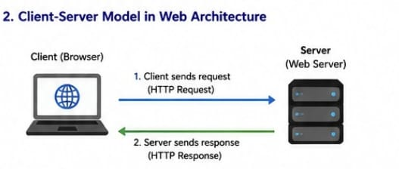

Q3. Describe how a browser requests and displays a web page from a web server.

ANS:-

1. User enters URL (e.g., https://www.example.com) in the browser.
2. Browser sends an HTTP request to the web server for that URL.
3. Web server processes the request and sends back an HTP response
containing HTML, CSS, JavaScript, images, etc
4. Browser parses the HTML to create the DOM (Document Object Model)
5. Browser parses the CSS to create the CSSOM (CSS Object Model).
6. Browser combines DOM and CSSOM to render the page.
7. JavaScript is executed to make the page interactive.
8. Finally, the page is displayed to the user.

Q4. Identify and list the tools required to set up a web development environment. Explain the
purpose of each.
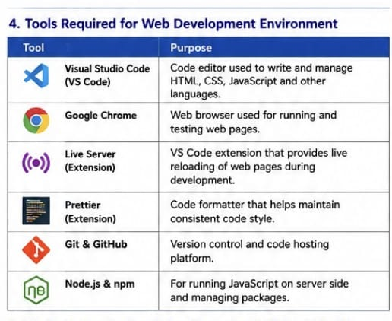
ANS:-

Q5. Explain what a web server is and give examples of commonly used servers.

ANS:- A web server is a software (or hardware) that stores, processes anc delivers web pages to clients (browsers) over the internet using the HTTP protocol.
Examples of commonly used web servers:
• Apache HTTP Server
NGIMX
Nginx
Microsoft IS (Internet Information Services)
LiteSpeed
Caddy Server

Q6. Define the roles of a frontend developer, backend developer, and database administrator
in a project.

ANS:-
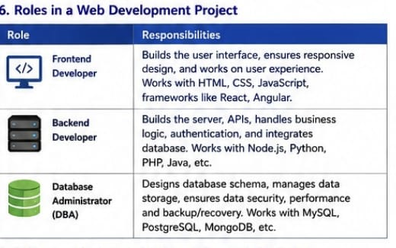

Q7. Install VS Code and configure it for HTML, CSS, and JavaScript development. Take a
screenshot of the setup.
ANS:-
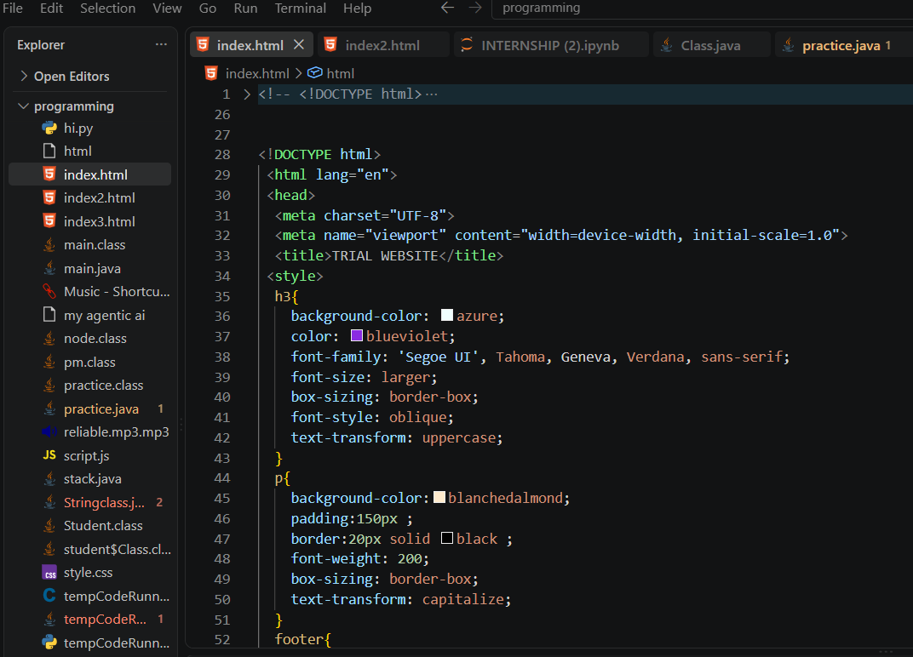

Q8. Explain the difference between static and dynamic websites. Provide an example of
each.

ANS:- 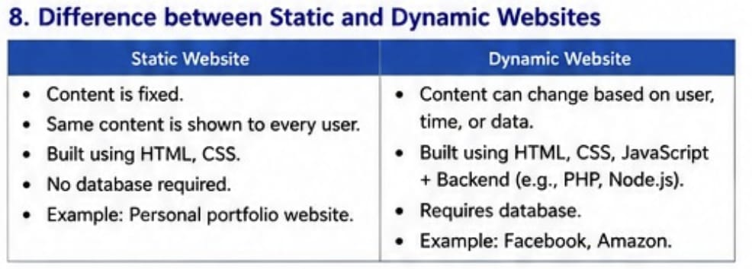

Q9. Research and list five web browsers. Explain how rendering engines differ between
them.

ANS:-
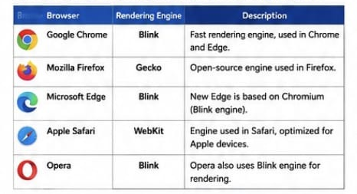

Q10. Draw a labeled diagram showing the basic web architecture flow — client, server,
database, and APIs.

ANS:- 